**KIGALI INDEPENDENT UNIVERSITY ULK**

**GISENYI CAMPUS**

**PO.BOX 243 GISENYI**

**SCHOOL OF SCIENCE AND TECHNOLOGY**

**DEPARTMENT OF COMPUTER SCIENCE**

INTERNSHIP REPORT AT OPTIMUM COMPANY

FROM 10TH SEPETEMBER TO 20TH OCTOBER

**By: Obedi OBADIAH MWENDAPEKE**

**Supervisor: Charmant MAMBO**

***Academic year : 2019-2020***

# **DECLARALATION**

I, **OBEDI OBADIAH Mwendapeke** declare that this is my internship report during my 6 weeks in information and communication technology field at Optimum Company (DRCongo, Goma city)

Prepared Date 10th September 2020

**Signature………………………………...**

**Supervisor: Charmant MAMBO**

**Undertaken Date………………………**

**Signature……………………………….**

# **APPROVAL**

My report is dedicated first to the Almighty God for his strength, to my family, my supervisor and company’s authorities for their support during my internship which help me to fulfill successfully my internship by gaining necessary knowledge for a good preparation of my future carrier.

# **Mr. Charmant MAMBO**

**Undertaken Date………………………**

**Signature……………………………….**

Our internship at Optimum Company provided to us both practical and theorical training from 2nd July to 10th August 2019.

As all internship everywhere is done according to the company’s policy and requirements for the award of the bachelor’s degree for all undergraduate students to be attached in the society during a little period.

First and foremost, I would like to acknowledge the Almighty God who unceasingly provides for me strength and makes everything happen successfully. Praise the Lord Jesus Christ for everything He has done, He is doing and He will do for me and especially for his grace which help me to be successful in whatever I do, let his name be glorified forever and ever.

My thanks also go to the all optimum company’s workers for their assistance and providence in necessary tools for increasing my knowledge in Computer Science’s field.

My deep gratitude goes to the manager of Optimum Company and to my internship supervisor, Joseph Likwaki for his tireless support throughout my internship. Despite his tremendous work academic and miscellaneous loads, he willed to supervise this work. His wise pieces of advice, his encouragements and whipping have made me upright and set me from my weakness.

My thanks are also directed to the Administrative Staff of Optimum Company for their encouragement, advices and cooperation to me.

Finally, I wish to acknowledge with thanks to my friends and classmates who have shared as many ideas a s possible during my internship.

Glory to GOD.

**OBEDI OBADIAH Mwendapeke**

# **ABSTRACT**

 I carried out my internship at Optimum Company in Computer Science department. Under computer graphic, I dealt with setting up, administering, maintaining graphic design project, and also installation and maintaining computer device. The activities carried out included printer installation, graphic design software installation (Photoshop, Premier Pro, After Effect, Adobe Illustrator. Under computer maintenance and repair, I dealt with basic hardware installation (RAM, HARDDISK, CD-ROM), basic operating system installation and activation i.e. windows Xp, 7,8,10, system restoration, file recovery, data backup, Wi-Fi hotspot creation. Through work and experiences, I attained graphic design skills, trouble shooting, team work, leadership skills, interpersonal and research skills, digital marketing. The challenges faced include: lack of enough equipment, faulty equipment i.e. CD ROMs, RAM, and crimping tool, understanding new technical terms. In my conclusion internship at Optimum company was so productive with practical hand on skills attained from different field supervisors. I recommend that we as students need to be taught much more of practical skills in class than theory and be given more time for practices.

# **LIST OF ABREVIATIONS**

AB : Adobe

PS : Photoshop

PR: Premier pro

AI : Adobe illustrator

Ae : After Effect

CC : Creative Cloud

OS : Operating System

PC : Personal Computer

PSU : Power Supply Unit

RAM **:** Random Access Memory

WLAN : Wireless local area network

HDD : Hard Disk Driver

IT : Information Technology

LR : Light room

GD : Graphic Design

ACC : Adobe Creative Cloud

AME : Adobe Media Encoder

JPG : Join photographic expert group

PSD : Photoshop Document

PDF : portable document format

RGB :Red, Green, and Blue

Px :pixels

2D : 2Dimensional

3D : 3Dimensional

4D : 4Dimensional

# **CHAPTER.1. GENERAL INTRODUCTION**

## INTRODUCTION

This field attachment report is about the skills attained, lessons learnt, and challenges. Relatedness of theory covered in class and recommendations during my internship placement at optimum company from 2nd July to 10th August. The report also represents my experiences, recommendations and benefits of the field attachment.

## 1.1. Objectives of internship

### 1.1.1 General objective

To find out the degree of relevancy of the theoretical knowledge acquired in classroom to the real state of practices.

### 1.1.2. **Specific objectives**

* To help students to find out how to combine what he learns in the class with the professional’s reality;
* To gain necessary skills that promote personal growth and development
* To be well prepared for new learning experiences and susceptible to challenges
* To enable how to handle problems within organization and find out solutions.

## 1.2. Significance of the training

The training is of paramount importance as it helps the trainee to accumulate the knowledge from the field which is helpful for his future employment opportunities.It is also a stepping stone in the fulfilment of the academic requirement for the award of bachelor’s degree in Computer Science.

It adds to the existing literature, guides for future practices and orientations to the researches as well as the improvements of the organization where the training was done from.

## 1.3. Methodology

Methodology is the overall approach used to gather and disseminate data from different parties. It includes methods and techniques used by the trainee to arrive at information obtained. It is therefore vital to mention the following modes utilized to come up with significant data.

### 1.3.1. Observation

The internee also managed to observe how some activities were performed. This also helped the trainee to have knowledge on various sections like executive office, management office, IT office, administrative office, Reception office, Technique office.

### 1.3.2. Interviews

Data was also collected by use of interviews. The trainee carried out interviews with different employees who were felt to have the necessary data. Questions were asked to various workers and the answers could be noted down which proved significant for the study.

### 1.3.3 Participation

For better understanding of the function of Optimum Company, the trainee actively carried participated in the computer graphic, maintenance and other relevant IT services.

### 1.3.4 Documentation

This is a research technique used to collect data from the existing literature for better understanding of a given phenomenon under study. The internee managed to acquaint himself with Optimum Company policy, register and other brochures of which all are available at the Sub- branch.

## 1.4. Time schedule

After being accepted internship training by Optimum Company, the time schedule is summarized within the table below in the time of 2th July to 10th August 2019**:**

|  |  |
| --- | --- |
| **DATES** | **DEPARTMENTS** |
| **2nd July 2019** | Acknowledgement of different tools of computer graphics |
| **11st-23th July 2019** | Evaluations of Computers and not then find out the problem and provide a necessary possible solutions |
| **24th July 2019** | Updating the operating systems (OS) |
| **25th -29th July 2019** | Identification of graphics software trend. |
| **30tH-2nd August 2019** | Downloading of the last version graphics software form the internet |
| **3th-25rd August 2019** | Installation of the last version of graphics software and checking of the software. |
| **26th-29th August 2019** | Installation of other feature of computer graphics |
| **10th September 2019** | Concluding by evaluating what has been done in the class (Theory) and in the Internship(Practice). |

**Source:** Own drawn

## 1.5. Problems encountered in the training

## Despite the knowledge that seemed interesting and the collaboration with the employees, the trainee faced disadvantages that had an impact on the quality of the knowledge acquired. We have therefore encountered various problems such as:

## • Lack of sufficient tools and limitation of internship time.

## • Unavailability of good device, which did not help us to do best work in rendering process (much time on the process).

## 1.6. Organization of the report

This report is organized into three chapters and arranged as follow:

* Chapter one consists of the general introduction of the training, objectives, significance of the training, the methodology followed and the problems encountered.
* Chapter two concerns the presentation of the organization including profile of Optimum Company location at Goma city, its historical background, its mission, vision, objectives.
* The third chapter deals with the activities that a trainee has been involved in during the training, recommendation and conclusion.

# **CHAPTER.2. BACKGROUND**

## 2.1. Optimum Company

Optimum Company in [DRCongo](https://en.wikipedia.org/wiki/Rwanda" \o "Rwanda), is a private company of Multimedia, technology, communication and digital Marketing.

## 2.2. Historical background

Optimum Company was created in 2014, After see Goma population growing and many enterprise has created it means multimedia, technology, advertising, marketing digital service as needed in the market. Eng. MOISE KASONIA is the founder and owner of the Optimum Company and Opticom Media.Optimum Company started its activities from KISANGANI city in DRCongo. After Kisangani, Optimum Companystart at 2016 inGoma city, their first office in Goma is localize Gallery de la justice, Rue Lyn Lusi, Q. Les Volcan /GOMA.

## 2.3. Infrastructure background

From February 2014 optimum company acquired Multimedia devices wich are: professionals Cameras, microphone, computers, camera lens, camera stand, tripod, large and small format printers and so more. vehicles; etc.

## 2.4. Services

### 2.4.1. Multimedia

Departments: Photography, videography, motion design, motion animation modeling …

### **2.4.2. Technology**

Departments: web developers, desktop applications developers, mobile applications developers, …

### 2.4.3. advertising

Department of publicity

### **2.4.4. digital marketing**

Social media account manager

## 2.5. Vision

Optimum company has the **vision** to stand out as a company of excellence in communication and technology company

## 2.6. Mission

The fundamental **mission** of optimum company is to provide to the costumer the good services to make them stand out of the competitions.

## 2.7. Social Mission

Despite Optimum company’s legal status of “private company”, meaning that functions using its own means, Optimum companyorganize some free training in multimedia and new technology

## 2.8. Philosophy of Optimum Company

The**philosophy** of optimum company is based on three fundamental principles:

* Creativity;
* innovatively;
* expertise;

## 2.9. Values of Optimum Company

The values of Optimum companyare “integrity and excellence”.

Optimum Company mission is: to satisfy, to serve, to optimize.

## 2.10. Objectives of Optimum Company

## Optimum company has the following objectives:

* Providing a solid and professional service;
* Providing services to the community;
* Creating competent human resources potential and endowed with moral and civic values;
* Organizing conferences and seminars to reinforce its collaborator and.

## 2.11. Kigali Independent University ULK organs are:

1. The Founder and President’s office;

2. The Executive office;

3. The Administration office;

4. The Management office;

Its doors are open to full-time to clients, who need to be partner’s andcollaborator

# **CHAPTER.3. ACTIVITIES DONE DURING THE TRAINING COURSE**

This chapter describes the activities carried out by the person in charge of such or such service and those which I carried out with the person in charge of the service. During my stay with the Optimum Company, we took part in the various activities of the Optimum Company

## 3.1. With the services of Computer graphic

This office is charged to conceive graphical contents.

In this service, the internee observe how the graphical content are conceived.

The internee also got knowledge in practical of design and conceive graphical content, to be used by marketing activities and visibility of clients.

## 3.2. Maintenance

The internee has seen and touch computers, printers, camera and its accessories to know more the problems a computer can affect and how to overcome them by assembling machine repair where there is a problem and then disassemble it again.This is what the internee saw in details

### 3.2.1. What is Maintenance?

It is an action which keeps the device working properly (known as repairing) or prevents troubles from arising.

**3.2.2 Computer assembling**

This term referred to computer maintenance, is the way of putting together different computer components to carry out computer system, in assembling a computer, the main points to consider are purpose, availability, compatibility, and cost**.** After having all required computer components, you prepare the best way of putting them together and that process need to follow stages.

## 3.3 Computer Dissembling

Disassembling a PC case can be a tedious job but it is necessary to know about it. Say, you want to upgrade your PC and put a new hardware component in it the steps we follow are:

**Step 1:** The very first thing you do when you disassemble a PC is to turn it off and disconnect all the power sources.

**Step 2:** Upon opening the PC’s case, you’ll see different things such as the video card, the sound card, the hard drives, the CD-ROM, and a lot of cables and wires.

**Step 3:** Expansion Cards: Interface card (ATA / Bluetooth / EIDE / IDE / Parallel /Serial / USB)

* + - * + Modem
        + MPEG Decoder
        + Network Card
        + Sound Card
        + Video Card
        + Video capture card
* **Step 4:** Disk Drives Floppy Disk Drives
* Hard Disk Drives, CD-ROM or DVD-ROM
* Unlike other drives, the hard disk drive is the only drive that is not physically accessed by the user like the floppy disk drive or the CD-ROM drive
* **Step 5:** Motherboard
* RAM (Random Access Memory)
* Central Processing Unit
* Processor
* Detach the RAM from the slot. Then, gently remove the Processor by pulling the lever up then picking it up.
* After putting every computer component on it is smoothly place you keep it running and continue for testing if computer system work very well. This Progress course may require several time in order to determine the computer necessity service for being produced in confirming time inside

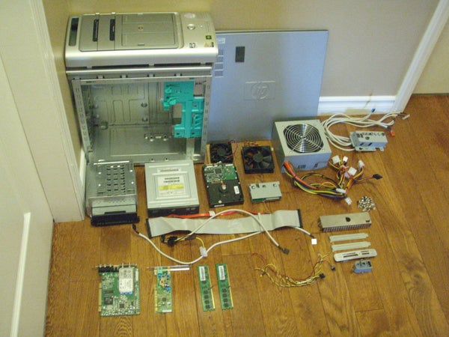

This sketch showing the best position of entire computer repairing in its some tools used to maintain a personal computer.

What PC maintenance strategies and tools do you use? Share your tips below and help make life easier for your fellow readers.

## 3.4 Computer Networking

In the field of computer networking the internee got the powerful knowledge about different devices that can make a network to be powerful.

### 3.4.1. Introduction

In information technology, Networking is the design, construction, and use of a [network](http://searchNetworking.techtarget.com/sDefinition/0,,sid7_gci212644,00.html), including management of the physical equipment’s of the network (cabling, [hub](http://searchNetworking.techtarget.com/sDefinition/0,,sid7_gci212294,00.html), [bridge](http://searchSecurity.techtarget.com/sDefinition/0,,sid14_gci211705,00.html), [switch](http://searchTelecom.techtarget.com/sDefinition/0,,sid103_gci213079,00.html), [router](http://searchNetworking.techtarget.com/sDefinition/0,,sid7_gci212924,00.html), repeater and so forth), the selection and use of telecommunication [protocol](http://searchNetworking.techtarget.com/sDefinition/0,,sid7_gci212839,00.html) and computer software for using and managing the network, and the establishment of operation policies and procedures related to the network.

### 3.4.2 Switch

A switch is computer networking component that joins multiple computers together within one local area network (LAN). Technically, network switches operate at layer two (Data Link Layer) of the OSI model. Network switches appear nearly identical to network hubs, but a switch generally contains more intelligence than a hub Unlike hubs, network switches are capable of inspecting data packets as they are received, determining the source and the destination device of each packet, and forwarding them appropriately.

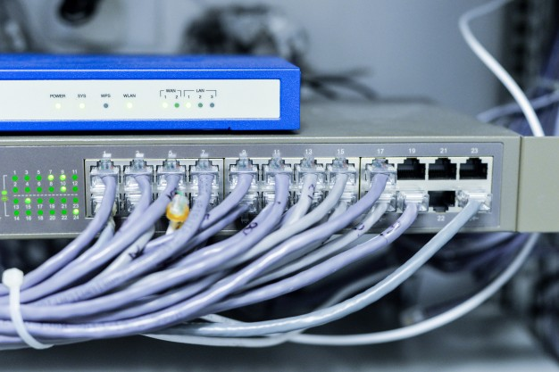

**Figure:** Switch with network cables

### 3.4.3 Repeaters

Used to extend the maximum distance a cable segment can span. Repeaters grab the incoming electrical signal from the cable, amplify it, and send it out.

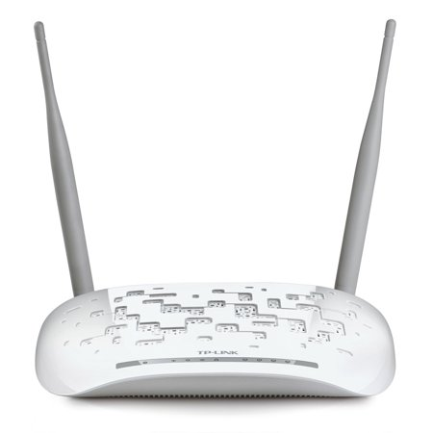

**Figure:** repeater

### 3.4.4 Hubs

Hubs, also known as concentrators or multiport repeaters, are used in star/hierarchical networks to connect multiple stations/cable segments.

**There are two main types of hubs**:

**Passive** and**active**, an active hub takes the incoming frames, amplifies the signal, and forwards it to all other ports; a passive hub simply splits the signal and forwards it.

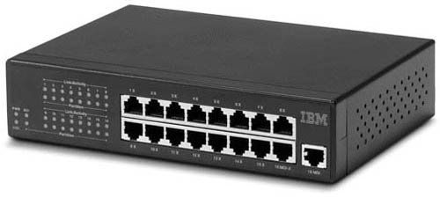

**Figure:** Hubs

### 3.4.5 Routers

Routers are used to interconnect multiple (sub-) networks and route information between these networks by choosing an optimal path ("route") to the destination based on addressing information from protocols such as TCP/IP or IPX/SPX. Router are also typically used to connect a LAN to a WAN or another LAN, which can use different technologies such as Token Ring, Ethernet, ISDN, Frame Relay etc.

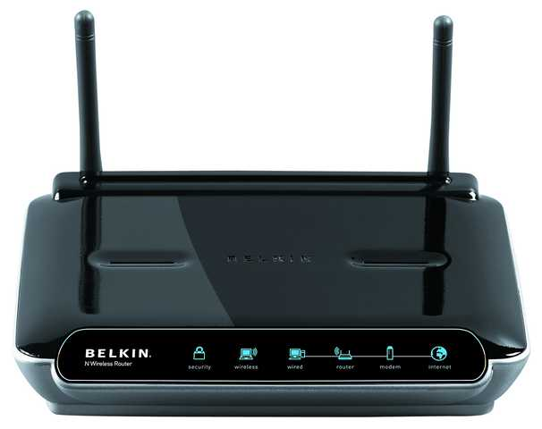

**Figure:** Router

### 3.4.6 Network interface controller

A network interface controller (NIC, also known as a network interface card, network adapter, LAN adapter, and by similar terms) is a computer hardware component that connects a computer to a computer network.

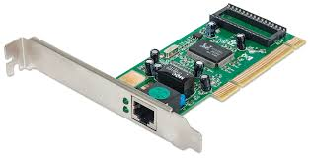

**Figure:** Network interface controller

### 3. 4.7. Network cable

A network cable is a twisted pair cable which is used for connecting network devices for sharing data.The network cable has eight small cables inside with different colors; those are in form of four pairs.

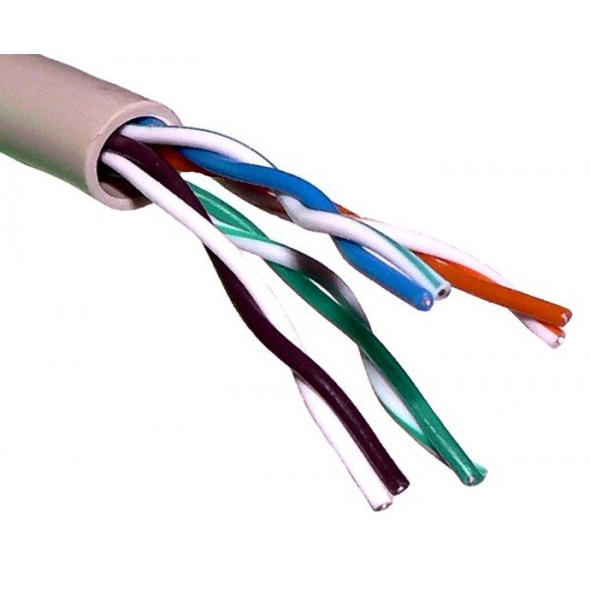

### **Figure:** Network cable

**There 2 types to connect cables**

**1st is Crossover cable**

Crossover cables are very similar to straight-through cables, except that they have pairs of wires that crisscross. This allows for two devices to communicate at the same time. Unlike straight-through cables, we use crossover cables to connect like devices.

Use a crossover cable when:

1. Connecting a router to a hub

2. Connecting a computer

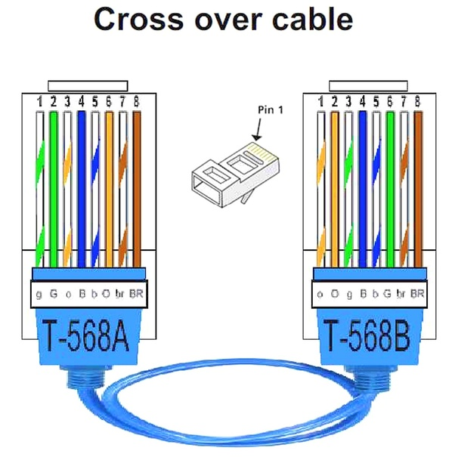

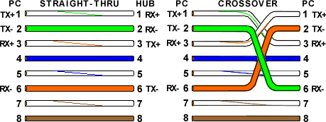

**2nd is Straight-Through cable (Rollover cable)**

Straight-through cables are primarily used for connecting unlike devices. A straight-through cable is typically used in the following situations:

Use a straight-through cable when:

Connecting a computer to a router

Connecting a computer to a computer

Connecting a router to a router

Connecting a switch to a switch

Connecting a hub to a hub



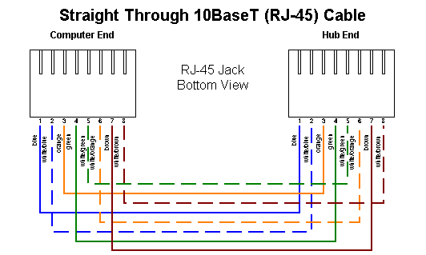

**4. Steps to set a patch panel**

1) Start by stripping off about 2 inches of the plastic jacket off the end of the cable. Be very careful at this point, as to not nick or cut into the wires, which are inside. Doing so could alter the characteristics of your cable, or even worse render is useless. Check the wires, one more time for nicks or cuts. If there are any, just whack the whole end off, and start over.

Begin to untwist the twisted exposed wires on your cable. Use caution so that you do not untwist them down inside the jacket. Once you have all the wires untwisted begin to arrange them in the proper order based on the pictures above. This stage can be a pain in the ass, especially some of the middle wires. Once you get all the wired arranged in the proper order, make sure your wire cutters are within reach then grasp them right at the point where they enter the jacket.

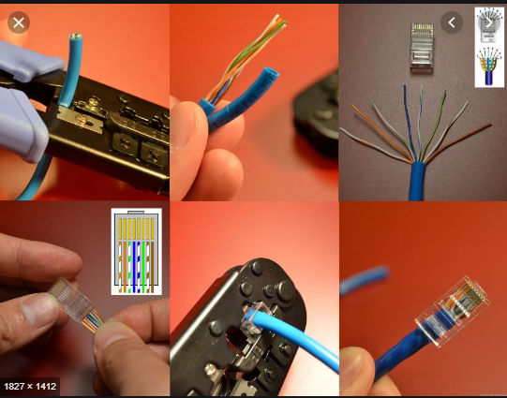

2) From this point forward things get a lot easier. Grab your jack, and begin to slide the wires into the jack. Once you get to the point where the jacket begins to enter the jack things might get a little tough, but just have some patience and hold onto those wires.





3) Grab those crimpers - because not all crimpers are exactly the same your pictures may not match exactly what you see below.

Be sure to keep a good grip on that jack and the cable. Insert the jack into the crimper. It should only go in one way, so you don't have a whole lot to worry about inserting it. Begin to compress those crimpers. You will more than likely hear a clicking sound.



4) It's time to examine what we have done. If you look at the end of the jack (distal), you should see that the copper connectors should not be pressed down into the wires.



5) In closing here to finalize this step we use tester cable.

This a device used for checking if the made network cable is working properly. One terminal of the cable is inserted in one of the two devices and the other one in the remaining device.

When the cable is good, there were a continuing moving light on both side of these devices, otherwise the cable was not good.

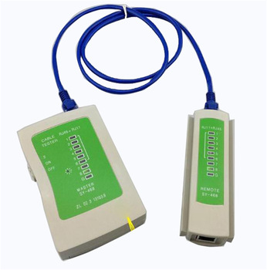

## 3.5 TYPES OF NETWORK

### 3.5.1. Local area network (LAN)

It is relatively small network for covering small areas like room, an office, a building, campus, home, etc.LAN can be wired (using cables) or wireless (using radio waves).

### **3.5.2.** Metropolitan Area Network (MAN)

Network that spanning a physical area larger than a LAN but smaller than a WAN, such as a city. A MAN is typically owned and operated by a single entity such as a government body or large corporation.

### 3.5.3. Wide Area Network (WAN)

WAN connects multiple LANs to one another over great geographical distance. It uses router to connect different LANs.

### 3.5.4. Other Types of Area Networks

**Wireless Local Area Network (WLAN):** A LAN based on [Wi-Fi](http://compnetworking.about.com/cs/wireless80211/g/bldef_wifi.htm)wireless network technology.

**Campus Area Network (CAN):** A network spanning multiple LANs but smaller than a MAN, local business.

**Storage Area Network (SAN):** connects servers to data storage devices through a technology like Fiber Channel.

**System Area Network:** links high-performance computers with high-speed connections in a cluster configuration. Also known as Cluster Area Network

3.6 Computer Graphic

3.6.1 Introduction

Computer Graphics is a branch of computer science that deals not only with producing

computer image synthesis. The term computer graphics includes almost everything on

pictures or images using a computer, but also dealing with the theory and techniques of

3.6.1.1 Overview

computers that is not text or sound. Computers have become a powerful tool for the rapid

and economical production of pictures. Advances in computer technology have made

interactive computer graphics a practical tool.

We find computer graphics to display Information in design, simulation, computer Art,

Entertainment as diverse areas of science, engineering, medicine, business, industry,

Further, the viewer's position and direction of view (camera orientation) must be

government, education and training.

Computers produce images by analyzing a collection of dots, or pixels (picture elements).

simple line drawings to three-dimensional reconstructions of data obtained from

**3.6.1.2 Definition of some terms**

**3.6.2.1 Computer graphics**

Computer graphics is a branch of computer science dealing with drawings or simply graphics

Createdusing computers and, more generally, the presentation and manipulation of image data by a computer with help from specialized software and hardware.

Computer graphics refers to any computer device or program that makes a computer capable of displaying and manipulating pictures.

Computer graphics generally means creation, storage and manipulation of models and image

Computer graphics is just creating or manipulating images with computer.

It covers 4 areas

1. Imaging = an image processing or representing 2Dimensional images

2. Modeling = representing 3Dimensional objects

3. Rendering = constructing 2Dimensional images from 3Dimensional models

4. Animation = simulating changes over time

3.6.3 COMPUTER GRAPHICS SOFTWARE

3.6.3.1 PHOTOSHOP

Photoshop is the most popular and use software digital photo industries processing by designers

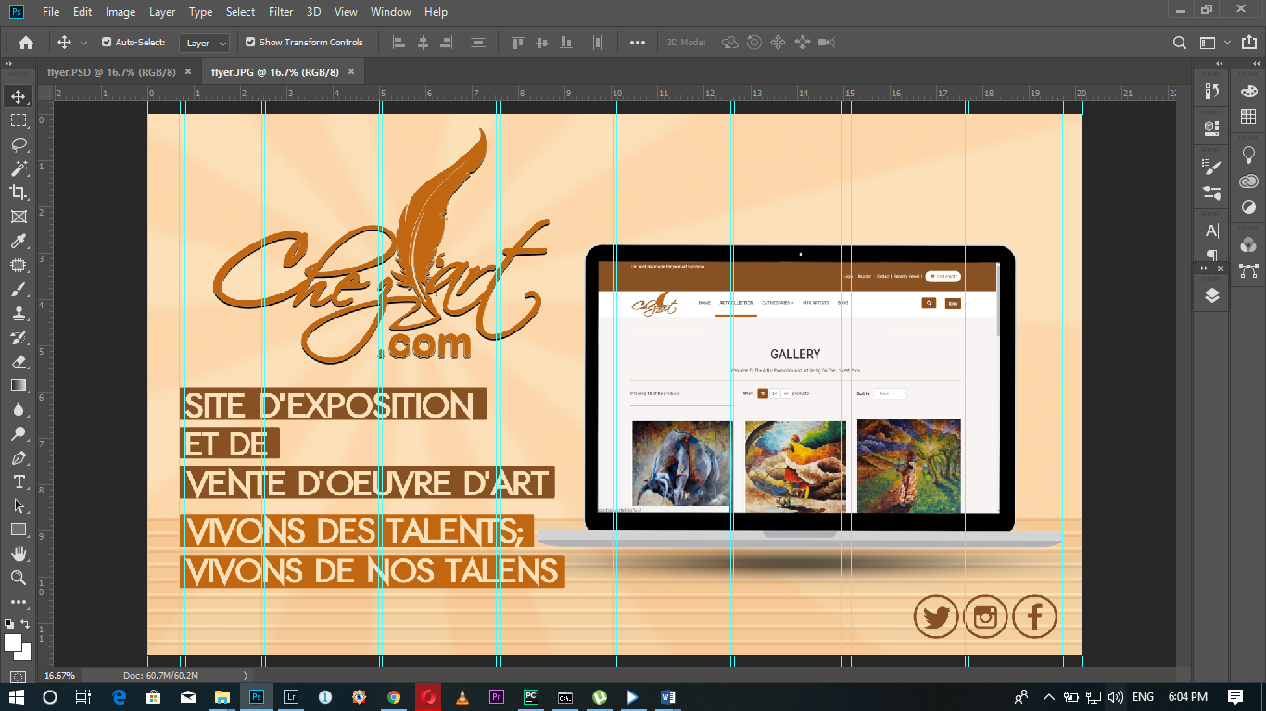

FIGURE: ADOBE Photoshop (Advertising Flyer design process)

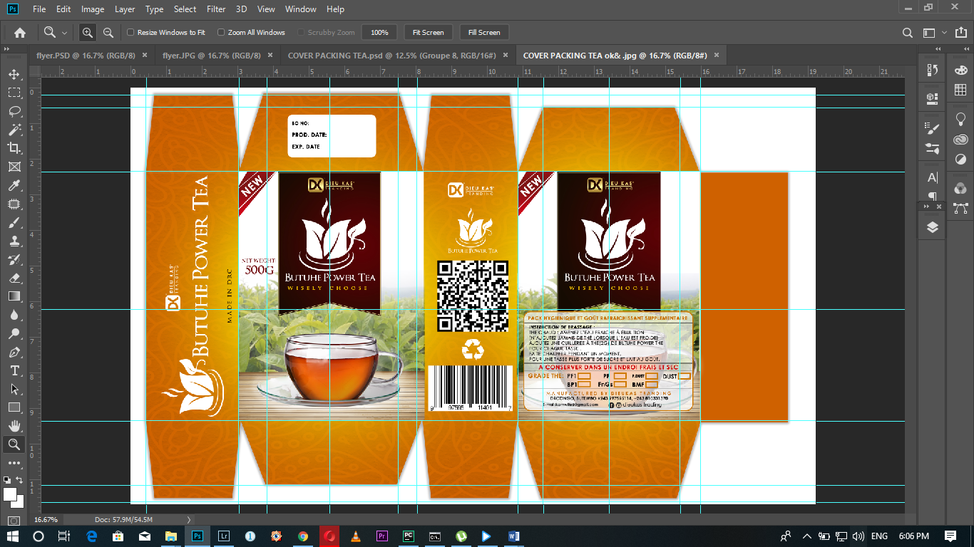

FIGURE: ADOBE Photoshop (Package design process)



FIGURE: ADOBE Photoshop (Logo design process)

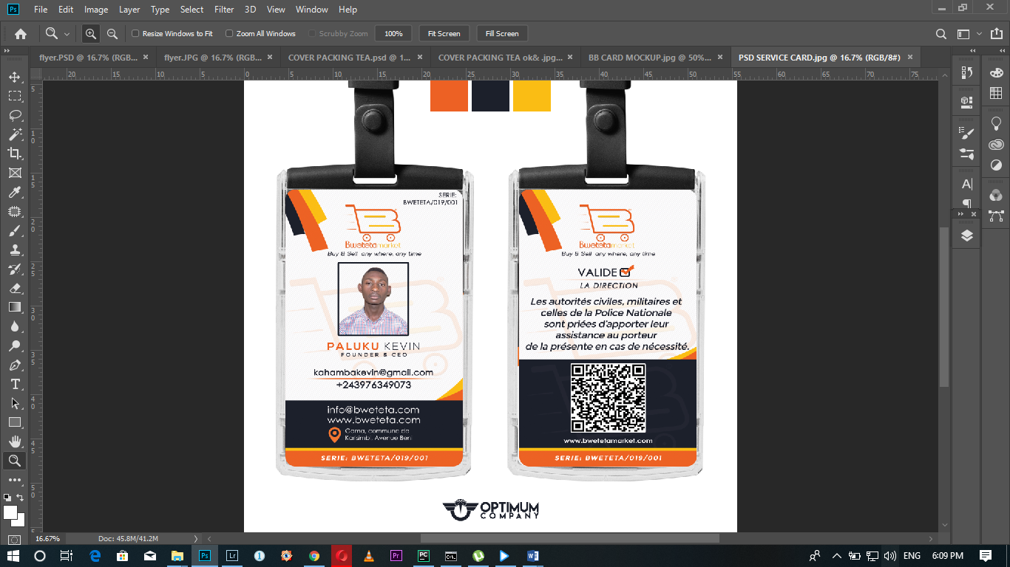

FIGURE: ADOBE Photoshop (Service card design process)

3.6.3.2PREMIERE PRO

Adobe Premier pro is video processing (editor and production) software, is use to edited films, publicities videos and so more.

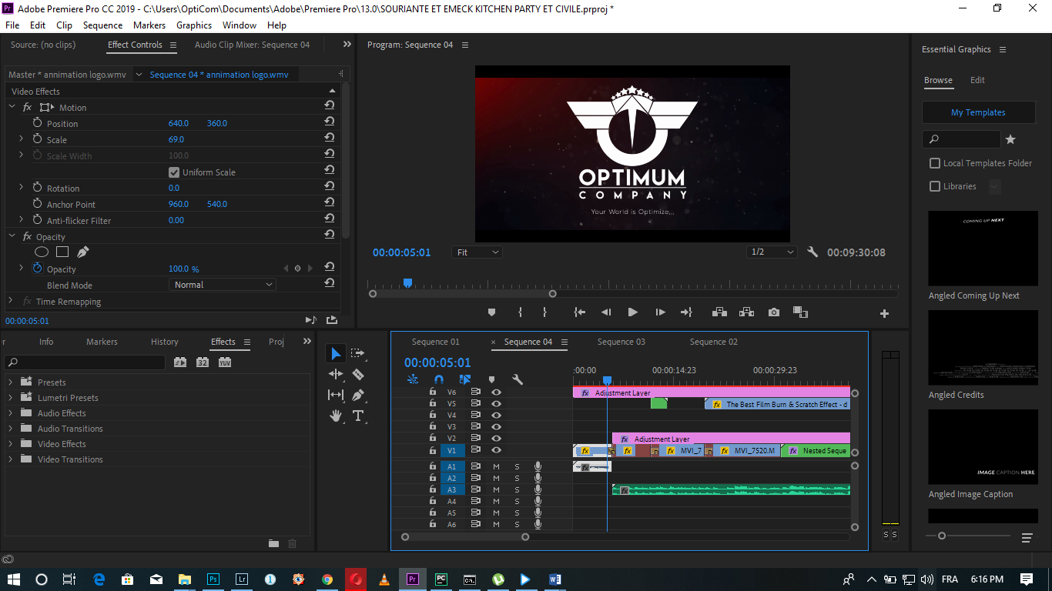

FIGURE: ADOBE PREMIER PRO (Vidéo Edition process)

**CONCLUSION AND SUGGESTIONS**

**CONCLUSION**

The internship carried out in Optimum Company was very interesting for me, I combined the theory I learned in class with the practices I’ve made in the internship I’ve made in Optimum Company. This helped me to know that theory only is not sufficient for someone to be what he/she wants to be in the future.

This training hasgiven me strength in my knowledge and it make me think big with practices combined with theory how it can be better in my future when it is combined and the experience I was given it is for me a strong capacity to adapt to any workplace, regardless of the nature of its activities. I thank the organizers.

**SUGGESTIONS TO OPTIMUM COMPANY**

Add more tools or materials for Computers which will help employees and internship personal to be flexible, more expertise and learn more.

Checking regularly the materials which will make research easier, good and awesome.

BIBLIOGRAPHY

Report of Internal Regulations of optimum company

+243 990 853 883

SOCIAC Media: Optimum Company

Prepared by: Approved by:

MOISE KASONIA SYAIKOMIAJoseph LIKWAKI

(CEO of OPTIMUM COMPANY)